Greetings RAIDER PARENTS AND FAMILIES,

We are excited to announce that starting Fall of 2025 we will be a full partner with BOUND, a full-scale athletic, activities, and facilities management system. This partnership will create a seamless and engaging experience for all RAIDER stakeholders - all our schedules, ticketing, scores and standings, and fundraising opportunities will be in one location!

BOUND Public Website - To get you started, click on the following link (be sure to bookmark this page). This is the landing page for RAIDER families, fans and students. You and your family will be able to get everything you need from this one site!

https://gobound.com/sd/schools/rapidcitystevens

Athletic Registration - To get your athlete(s) registered for the spring sports programs, click on the ‘Registration’ link at the top of the Rapid City Stevens Raiders Bound public site. You can also scan the QR code on the attached Activity Registration flier.

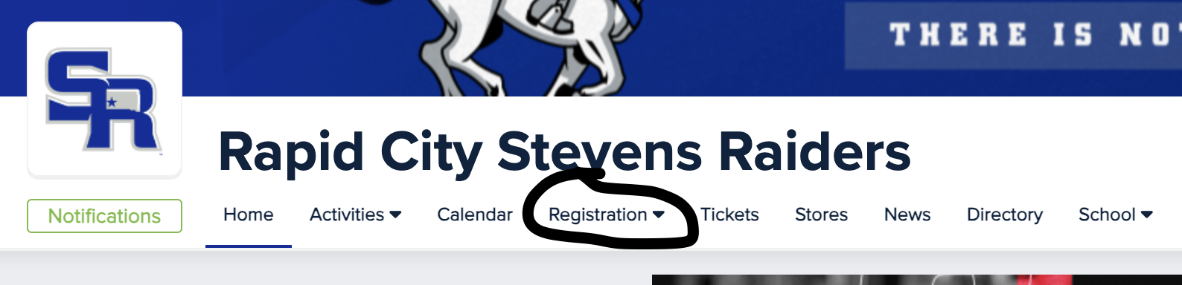

From here, you will be able to connect your family (parent and student accounts), enter or update all important demographic information, upload your current physical, sign off on all of the required documents for participation, and register for the sports your athlete(s) intend to participate in this school year.

Here is a step-by-step document to get you started on the Athletic Registration process: https://intercom.help/boundhq/en/articles/7934242-registering-your-student-for-an-activity

Part of the registration process is to search for your student under Rapid City Stevens Raiders. Because this platform is new to us if you do not find your student in the search field - go ahead and choose I CAN’T FIND MY STUDENT (CLICK HERE) at the bottom of that pop-up window. Then add your student and proceed with Registration.

*NOTE-If your student has participated in any sport during their time here at RCSHS they may already be in our database, and you can proceed to STEP 3 on the flier clicking on the 24-25 school year. If not, you will MANUALLY add your student. Check by typing their name BEFORE you add.

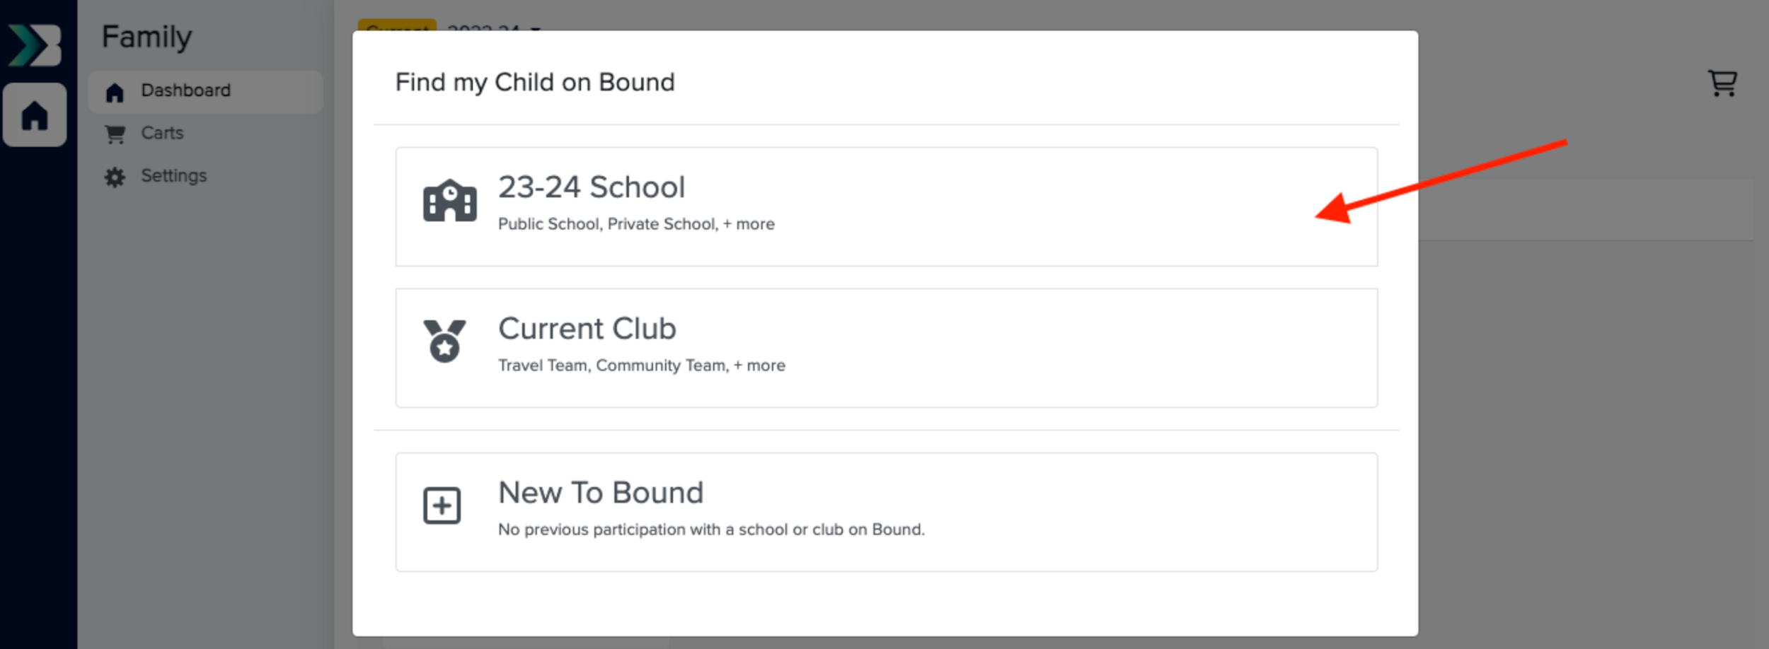

*ALSO NOTE-If your child is a member of two households. Please use the directions linked below.

https://docs.google.com/document/d/1icYSeuKYVwgZ39OqsYv4K9ZKHqjAAe4KWrR0NTJ_i40/edit

Notifications - As parents or guardians of active RCSHS students, you need to keep up with any changes or adjustments to schedules in real-time. By utilizing the “Notifications” feature in Bound, you will be able to sign up to receive notifications of changes, postponements, or cancellations in scheduled events. At the top of the RAPID CITY STEVENS RAIDERS Bound public site, notice the green “Notifications” button below our mascot. This button is in the same location on each page as you navigate from activity to activity.

If you want school-wide notifications, click on this button on the Home screen and sign up - name, email, phone number and what notifications you would like to receive. From there, navigate to the activities your student(s) are participating in or ones you want to follow and do the same. For example, if you want girls basketball notifications, you will click on Activities and basketball. Once you land on the basketball home page, click on the ‘Notifications’ button and sign up for notifications specific to soccer. Repeat this process for any activities you need to stay up to date and in the know!

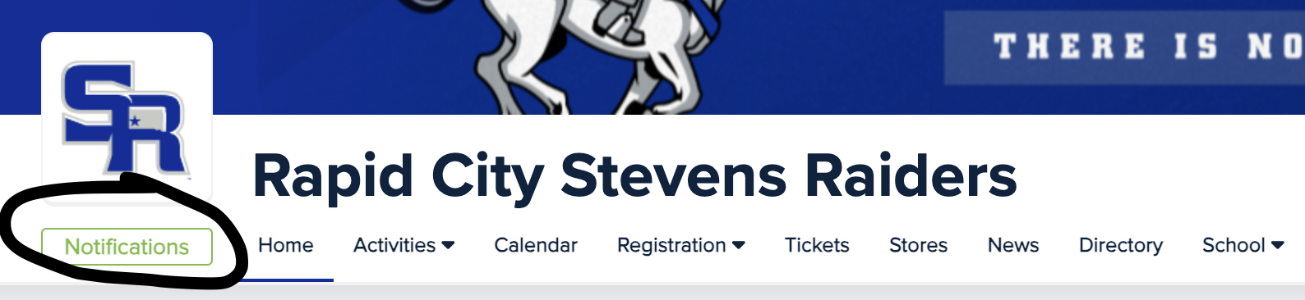

Schedules, rosters…and more - We would invite you to take a test drive around the site while you are there. Click on the links at the top of the page, you’ll see all of the activities that we offer at RCSHS. This site will be your one stop shop for your family’s athletic and activities information and resource needs.

Tickets and Passes Information - We will be offering digital ticketing options for the upcoming 25-26 school year. Rapid City Stevens is excited to offer this option and make the gate admission process easier and more convenient for our families and students. We will be offering several admissions pass options to help you and your family save money all year long at our home events - including the (include your pass options here - all sports pass, student pass, flex passes, etc.). You can pre purchase your passes or individual tickets online ahead of time OR make use of our credit/debit card readers at the gate. No more scrambling to remember to stop by the gas station on the way to the game to get cash…use your card or Apple Pay at the gate. Click on “Tickets” at the top of the Rapid City Stevens Bound public site to begin your ticketing experience today.

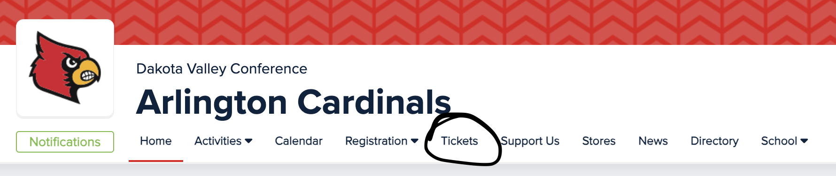

BOUND APP - BOUND is available on any smart device under "Bound Sports." Please download the app for you to have access to your student(s) athletic program notifications on the go! You can scan the QR code on the flier from your phone to get started! You will need to select ALL the programs you are interested in if this is your first time.

IMPORTANT NOTE: When downloading and logging in to the app for the first time, it is crucial to use the same email address that is associated with your family account. It works just like any other app/shopping site, if you create an account on the computer, you must log in to the app with the same email address and vice versa.

For Bound support you can click the B in the lower right corner. There are a couple questions to help guide us, but rest assured there is a person on the other end who will help you. You can also email support@gobound.com for assistance.

Thank you,

Nick Karn
Stevens High School Activities Director

